Programming Exercise

This PE is heavily based on the code you created in this week’s HOS.
Create a RESTful API using Flask that allows users to manage their to-do lists.
Users should be able to create, update, delete and retrieve to-do items via the API.
Here is a flow of interactions that your app should support.
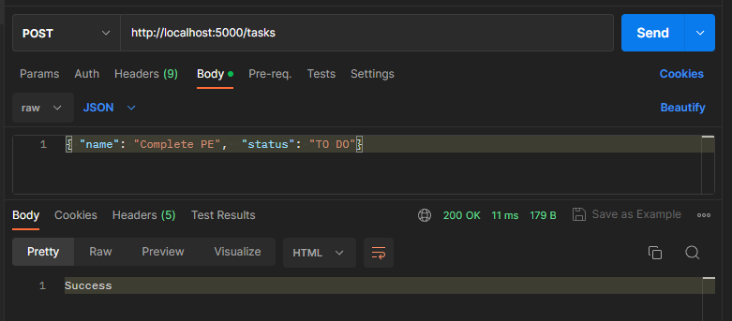
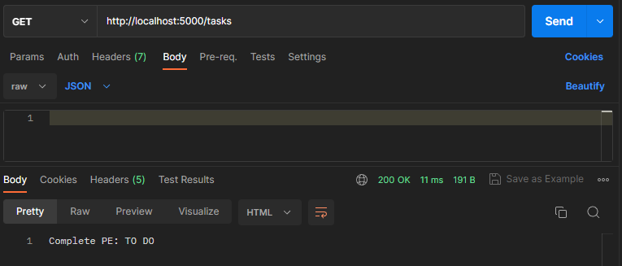
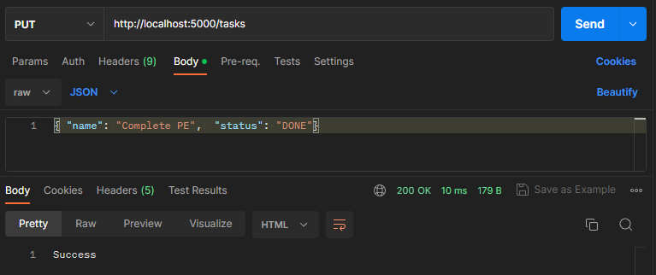
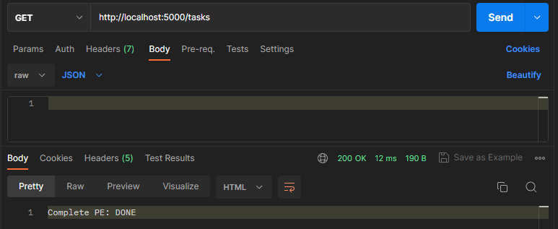
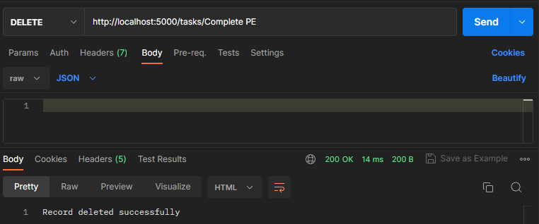
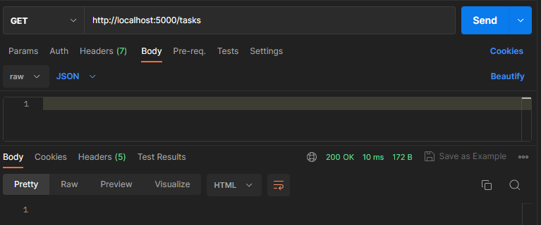
Submit the items below to the PE submission page:
- app.py file including comments with an explanation of your changes
- A 50 to 100 word analysis for each of the questions (with screenshots if necessary) in the PE question document.
  - Make sure the PE module number and your name are written on the file name, e.g., "PE01_Name.docx").

